INSPIRING TEACHERS
ELT PLAN TEMPLATE

Complete with the information about you
Author
Teacher´s name | María Cristina Pineda Arboleda
Email | kristancha_2011@hotmail.com/crisorland1987@gmail.com
School | Institucion Educativa Pio XII (Florencia, Samaná)

Select the type of plan
Lesson plan | Activity plan | Task plan | Project plan
 |  |  | X

Write a few lines about the usefulness of this plan for the Colombian English teachers
Example: This lesson plan gives the students a chance to know about you, their new teacher, and it also gives you a valuable opportunity to assess your students' level. It can also be a useful and productive class if you ever find yourself substituting a class at short notice.
Author’s remarks
This plan will give the teacher the opportunity to transversalize some subjects in one topic and; on the other hand, students can make different task that will be in a complete prevention plan at the end of the class. Also, the teacher can adapt or modify the context (rural or urban); Finally, the implementation of different types of formative assessment can be found.

Complete with the information about your students
Grade | Length of lesson | Number of students |  | Average age
8th | 7 – 8 hours | 20 |  | 13-14
Area |  | English level
Rural X | Urban | A1 X | A2 |  | B1

Select the curricular axe or focus
Curricular Focus / Axes
Environmental / Sustainability Education
Sexual / Health Education | X
Construction of Citizenship / Democracy / Teenagers
Globalization

Complete with information about the content and methodological approach of the plan
Topic | Eating Disorders
Module / Unit | Module 2: Health
Language focus | Language Function | Language skills | Vocabulary
 | Identifying and describing good eating habits. | Reading, writing, listening and speaking.
Principles / approach | Project Based Learning (PBL).

In “Aim”, state what the learning goal is, in other words, what you want your students to achieve by the end of the session.
In “Subsidiary aims”, relate the language skills (communicative and linguistic) students need to master in order to achieve the main aim of the lesson. Make sure the aims are learner-centred, specific, measurable, achievable, realistic, and action oriented.
Learning objectives
Aim | By the end of this lesson, students will be able to give recommendations for better eating habits through different activities.
Subsidiary aims | By the end of this lesson, students will be able to …  - Use positive language in context  - Identify symptoms, parts of the body, and treatments in a brief and simple written text.  - Recognize negative health practices.  - Formulate prevention plans about eating disorders.

List all the materials needed for this plan. Please, do not include any picture or photograph.
Materials needed
Board, markers, cardboard, paper of different colours, glue, scissor, bracelet of different colours.

Write the name for each state of the plan. Then in the “Procedure”, write a detailed description of what the teacher and students do at each stage of the session.
Be sure to be thorough so any teacher can follow this plan. Write the procedure in third person and present tense.
Use these conventions: T= teacher S= students Ss= students
Stage | Procedure | Time and Patterns of interaction
Warm up:  Ice-breaker | T tells SS that they will play a game called SIMON SAYS. The idea is to remember some vocabulary about the parts of the body. T shows to SS with his/her hands any part of the body, at the same time that he says a word. The idea is that students can identify immediately the word they hear and touch it in their own bodies. SS shouldn’t get confused with the body part T touches, but they only concentrate on the part the hear. | 10 minutes  T-SS  Individual work
Introduction:  presentation of the project | T presents the project. SS are divided in groups of 5 people. Each student chooses a role to play (1. leader, 2. Skater, 3. Secretary, 4. Chronometer, 5. model), per group.  T presents a guiding question: How can students prevent an eating disorder?  After, SS choose the role; each one will have the functions that the T gives to them; for example:  The (1. Leader) should control the team, he/she draws the silhouette of a classmates (5. model) on a cardboard.  After that, another student (2. skater) picks up some sentences about the parts of the body, there will be 20 phrases on the floor for example “if you don´t eat healthy food, you will suffer stomach-ache” … if you see a fat body on the mirror, you probably will suffer of anorexia” … the skater can take just one per turn.  The rest of the members of each team should put all the phrases over the correct places of the silhouette. The (3. Secretary) student takes notes in a separate piece of paper of all phrases that the skater could select.  Finally, all teams should explain what the relation is between the phrases chosen and a specific part of the body. It is important that the chronometer (4) takes the time because each team has just 5 minutes for explaining. The leader presents the final task by reading the notes elaborated by the secretary. | 30 minutes for all activity  T-SS  Team work  The chronometer students take time and the teacher too  10 minutes  5 minutes for each team  20 minutes in total  During the process
Assessment: The teacher checks comprehension activity by using CATs (classroom Assessment Techniques).

HAND SIGNAL: T asks SS “Everybody has a function?”, they will answer yes or no with their hands.

A thumbs up means “yes, it is clear” or “yes I have one” depending on the questions.
A thumbs down means “No, it isn´t clear” or “No, I don’t have one, depending on the questions.

Other variation could be T asks questions such: Were instructions clear? To check students´ understanding
5 fingers up mean: All is clear.
3 fingers up mean: I have some doubts
1 finger up means: I don´t understand.
Development  Lesson 1: | T pastes around the classroom 21 concepts related to parts of the body and SS select at least 10 of them.  SS get in pairs and answer some question in order to identify the key. For example: What is the part of your body that can clean all the blood? (The answer is kidneys).  T should go solving doubts about that if SS need something related to the topic. | 20 minutes  SS-SS  individual work
Development  Lesson 2: | There are 5 types of reading with different colours for each one about eating disorders; they are cut into 3 pieces, and all these pieces are pasted around the school. T shows to SS some bracelets with different colours that match one of the split readings previously mentioned.  - T asks SS to make groups of 4 (several grouping techniques can be used, for example, lions are coming).  - SS have to go outside and find all three pieces of the reading that correspond to their same colour.  - SS gather and put together all pieces so that they have a complete reading (it has to make sense).  HAND SIGNAL (CATs)  T checks understanding of instructions before SS go outside.  T asks SS to close their eyes, and use their fingers to answer these questions:  - Are the instructions clear?  - Are the pieces of reading outside the classroom?  - SS could answer with they want: a thump up/down or 5,3,1 fingers.  - Finally, each group makes a summary about the reading through a mental map to explain in class. | 30 minutes in total  T-SS  15 minutes  SS-SS
Assessment: Peer Assessment. FEEDBACK SANDWICH
T will give SS feedback sandwich template and asks them to complete with the following aspects:
1_________
1. Give a positive comment to your classmates.
2. Provide a constructive criticism with explanation of how to improve the mental map.
2_______
3_______
3. End with a positive comment (or more) that encourages and motivates your classmates.
T shows an example of the feedback sandwich, then SS return their works and the feedback sandwich template. SS read the comments and improve their mental maps.
Development  Lesson 3: | Scavenger hunt!  SS have to search for some clues around the school and answer all the question or cases presented.  T gives SS a route by working in pairs with 5 different steps or instructions where they should find some cases about eating disorders. For example:  Step 1. what is the place when you practice sports every day in your school? In this place they find some clues about possible cases of eating disorders.  Example:  CASE 1. Yuliana doesn´t have control of the food that she eats, possibly she suffers of___ binge- eating___  CASE 2. Sebastian is having an obsession with losing weight, if he doesn´t eat very well, he will suffer from_____?___  After that, SS will discuss with their classmates and identify the eating disorder by writing the correct name for each condition.  Step 2. There are many books and posters that help us do our homework (library). In this places SS also find other kind of cases.  Finally, the pair that has more cases solved will be the winner. T can give some extra points for SS by encouraging them to improve every day or maybe to draw a happy face in their routine. | 30 minutes  SS- work in pairs
Development  Lesson 4: | - T gives SS an example of how they can express conditions or suggestions and asks them to identify the causes of eating disorders. T uses all the phrases that were given in the previous lesson, for example: “if you don´t eat healthy food, you will suffer stomach ache.  T tells SS that they should pay close attention to colours used because those expressions are conditions or consequences that correspond to first conditional.  Assessment: STOP AND GO. (CATs)  T gives two pieces of colours for each student.  RED CARD: I don’t understand!  GREEN CARD: it´s clear teacher, I understand!  SS can show the colour card when the T asks them something related to the topic.  By using all material recollected in the former lesson, SS have to identify the conditional structure in each one for being practiced in class.  - To make a role play by working in groups of 3 students about “a visit to the doctor” they should show us which the eating disorder is. Ask about experiences, express conditions, and make suggestions.  SS should take into account the following rubric for assessing the role play:  Great job! and all aspect are excellent 100%  Good job, but you have to improve some aspect. You need practice 70%  There are some aspects about the topic, but it is important that you improve for another opportunity 40%  There isn’t any aspect about the topic. You have to present again 10%  CRITERIA 10010000dfgj  Tittle The tittle is according to the eating disorder There is a tittle, but it doesn´t relate to the story There is a tittle but it has some mistakes and doesn’t relate to the topic There isn´t a tittle  Characters Main characters are clearly and all members participated Main characters are identified, but just two or one can participate It´s difficult to tell who the main characters are There aren´t any characters of the story  problem It is easy for reader to understand the problem and why it is the problem It is easy for reader to understand the problem but the reader doesn´t know why it is a problem There is a problem, but it isn´t clear There isn´t a problem  Prevention plan There is a prevention plan that is completely connected to the topic and helps understand better (first conditional and suggestions) There is a prevention plan that is connected to the topic and helps understand better (first conditional) There is a plan but it isn´t connected to the topic. There is not a plan or it is not related to the topic  Pronunciation and spelling All words are correctly pronounced and spelled There are some pronunciation or spelling mistakes, but no more than 4 There are 5 or more pronunciation and spelling mistakes There are several pronunciations and spelling mistakes | 1 Hour  T-SS  SS- group work  1 Hours  SS work ins groups of 3
Consolidation | In groups, create a prevention plan for a specific eating disorder that you choose to research. The purpose is to raise awareness about the disorder at your school’s Health Fair.  SS can use the mental map (development: lesson 2).  Finally, SS should consolidate the prevention plan by taking into account the weight and size of all primary students and give them some tips to prevent eating disorders according to their English level through a brochure or different visuals tools (pictures, posters, graphical, etc). | 2 Hour  SS-SS  Group work  SS 40 minutes
(Summative) Assessment: Testing. T gives SS a test that they answer according to the topic.

See Appendix section.

Self-assessment | Self-assessment: SS do their self-assessments about their performance in the project by using emotions for that and all steps.  criteria Statements I can do this I can do this with help I cannot this  vocabulary I can understand vocabulary related to eating disorders.  grammar I can describe symptoms of eating disorders and express conditions or suggestions  Reading I can understand texts about eating disorders.  Writing I can write about eating disorders.  listening I can speak about eating disorders.  Speaking I can describe minor illnesses and make suggestions. | 10 minutes  SS  Individual work

List a series of ideas of how this plan can be methodologically adapted so other teachers can implement it in their own educational context.

Implementation alternatives
I work in a rural area, but if you are working in an urban area, I consider that this plan can be also taught there because the topic of the lesson is very interesting and meaningful. In order to develop the topic, you can search for more information in the web sites below.

Cibergraphy:
http://kidshealth.org/en/kids/csquiz.html
http://www.saberingles.com.ar/lists/body.html

Bibliography:
Way to go teacher`s guide 8º
Student book way to go 8°
Workbook way to go, 8°

Write the key word for each category based on the content of this plan. For example:
Topic: environment Skill: reading Linguistic: should Vocabulary: animals, environment
Key words
topic | skill | linguistic | vocabulary | grade
Eating Disorders | Reading  Writing  Listening  Speaking | First conditional, suggestions. | Parts of the body  Food | 8th

APPENDIX SECTION

Name: _____________________________Grade: ________________ Date: _____________________
Read the following announcements and select the correct answer by writing it down on your answer sheet

1.
BREAKFAST FROM
7:00 TO 10: 00 AM
In a café
In a bank
In an office

2.
Drink before JUNE 2017
On milk
On bread
On ice cream

3.
3x2 buy tow chocolates and take three
In a classroom
In supermarket
In a parking

Read the following descriptions in the left column (4-8) and the words in the right column (A-E). Which word (A-E) matches the description of each phrase on the left
DESCRIPTIONS | WORDS
4. When your body temperature is above the normal range, you have… | A. Diabetes
5. What do you call it when a person has high blood sugar? | B. The brain
6. You can see all around with… | C. A fever
7. It´s like a mechanic into your head… | D. You will feel sick.
8. If you don’t eat healthy food, | E. Eyes

Complete the condition with the correct form given in the box, answer on the answer sheet
you might get a stomach ache B. you will become thin C. You will feel sick D. you won’t get better

9. If you get a virus, ______________________________________________.
10. If you don’t take the pills, _________________________________________.
11. If you don’t eat enough food, ________________________________________.
12. If you don’t eat before taking pills, _______________________________________.

Express and writing the condition with if and the consequence with will or might.
13. (not brush your teeth / get toothache) ____________________________________________.
14.(eat too much food / get a stomach ache) _____________________________________________.
15. (feel sick / not be happy) ________________________________________________________ .
16.(become thin / suffer from anorexia) ________________________________________________ .
17. (don’t get better / go to hospital) ____________________________________________________.

18. Match the picture a-e with the phrases
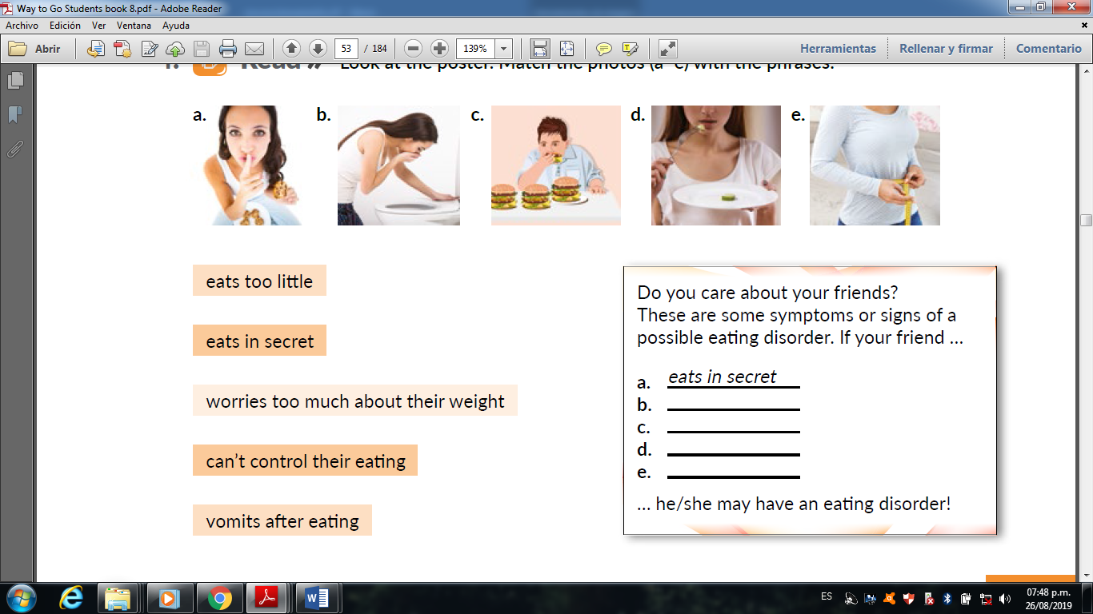

14. Read the following cases and identify for each of them the eating disorder given in the chart.
Tomas is
really thin, but he eats a lot. In fact, sometimes he eats so much food that he feels uncomfortable. I have also noticed that he always goes to the toilet a couple of times after eating. It is possible that he suffers from________

Lately, Jenny has lost a lot of weight. She hardly eats any food because she thinks she is fat, but in reality she is very skinny. Maybe she suffers from __________.

Maria Paola has put on weight lately; I don’t think she can control what she eats. I often see her eating in secret when she thinks no one is watching. I think she suffers from__________.

Anorexia
Bulimia
Binge-Eating

Answer sheet:
 | 1 | 2 | 3 | 4 | 5 | 6 | 8 | 9 | 10 | 11 | 12
A
B
C
D
E

