INSPIRING TEACHERS
ELT PLAN TEMPLATE

Complete with the information about you
Author
Teacher´s name | Danit Lucía Cardona Viana
Email | Danitcar@hotmail.com
School | Institución Educativa Distrital Inocencio Chincá

Select the type of plan
Lesson plan | Activity plan | Task plan | Project plan
 |  | X

Write a few lines about the usefulness of this plan for the Colombian English teachers
Example: This lesson plan gives the students a chance to know about you, their new teacher, and it also gives you a valuable opportunity to assess your students' level. It can also be a useful and productive class if you ever find yourself substituting a class at short notice.
Author’s remarks
This plan gives ss enough tools to develop the oral skills while talking about their plans for a near future. It encourages Ts to think about motivating activities, professions and facts that can encourage ss to learn English in a meaningful way.

Complete with the information about your students
Grade | Length of lesson | Number of students |  | Average age
7th | 3 hours | 37 |  | 12 – 13 years old
Area |  | English level
Rural | Urban X | A1 X | A2 |  | B1

Select the curricular axe or focus
Curricular Focus / Axes
Environmental / Sustainability Education
Sexual / Health Education
Construction of Citizenship / Democracy / Teenagers | X
Globalization

Complete with information about the content and methodological approach of the plan
Topic | Our future plans
Module / Unit | 3/Talking about future plans
Language focus | Language Function | Language skills | Vocabulary
 | Sequencing a future time line | Writing and speaking | Shopping  Study  Work  Some professions
Principles / approach | Topic based approach

Learning objectives
Aim | By the end of this lesson, students will be able to explain the projection of their lives in terms of professional and personal life.
Subsidiary aims | By the end of this lesson, students will be able to …  - List the different activities they plan to do in the future.  - Design a time-Line with professional and personal activities.

List all the materials needed for this plan. Please, do not include any picture or photograph.
Materials needed
Printables:
- Actions Charades Game Cards
- What are you going to do … ? True or False Board Game
- Reader worksheet
- Weekend Plans Write worksheet
Supplies:
- dice – enough for one per group of 2 or 3 students
- counters – enough to give one to each student
- board with markers / chalk
- photos of two people

Stage | Procedure | Time and Patterns of interaction
Warm up | Review activity:  T asks Ss to follow the actions he will mention: vocabulary game "Actions Charades"  Symon says: Dance, Jump, turn around, walk and be in silent  Guessing game:  T starts the class by organizing students in groups of 3 or 4, seated in around a table in order to model the activity. T gives all ss a set of flashcards and ask ss from each group to come to the front and Look at a card (not showing the class) Then those ss act out the verb on the card (e.g. kicking a ball, hitting a tennis ball, throwing a basketball, etc. for the “play a sport” card) until someone shouts out the correct answer.  Groups now play charades – T puts the cards face down, in the middle of the table. One student picks up a card and acts out the verb. The first student in the group to guess the answer wins a point. Continue with the next student until all the cards have been used up. Make sure you are on hand during the game to help with any vocabulary issues. The player with the most points at the end is the winner.  Ss get in pairs and answer… | 20 minutes  T-SS
Pre-task | My future activities  T Writes on the top, left-side of the board “This weekend” (or “Next weekend”, depending on which day of the week it is). Then He Picks one of the cards from the charades game and writes the words from it on the board, e.g. “go shopping” (see board layout below). T needs to make it clear that he is going to go shopping this weekend – points to himelf and the phrases on the board, nodding his head and saying “Yes”. T Puts a check mark (✓) next to the activity. Points to a few students and asks, “go shopping?” and elicit “yes” or “no”.  Next, write “I am going to” on the board. Say “This weekend, I am going to go shopping”.  Point to one of the students who says es, and ask “What are you going to do this weekend?” Make sure the student answers “This weekend, I am going to go shopping”.  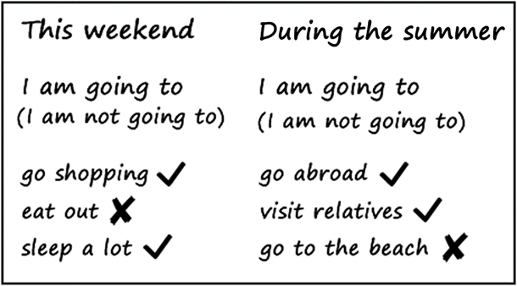  Next, T asks a student who said no and elicit “This weekend, I am not going to go shopping”. Write “I am not going to” on the board.  After this, T writes two more activities (e.g. “eat out” and “sleep a lot”) on the board and follows the same procedure, getting students to say the structure.  Next, on the right-side of the board T writes “During the summer” and again writes three actions on the board and asks students to say the structures. | 35 minutes  Ss – ss
Main task | “Wh” questions for a questioning classroom:  T is going to get students extend their conversations by introducing questions. Wipes the board cleans and sticks 2 photos of people on either side of the board. As a class, SS are going to write a conversation (see the board layout below) and they will start by drawing a speech bubble from the left person photo and inside write:  T Elicits and writes the missing words “What are you going to do this weekend?”  Then from the right person photo draw another speech bubble:  Again, T elicits and writes the missing words “I am going to go shopping.”  Now T continues with the conversation, draws a large speech bubble from the left person photo and write:  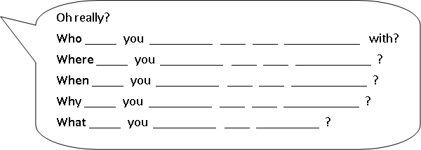  Ss copy the text from the board into their notebooks and then T asks them to work in pairs to fill in the blanks. After a few minutes, students come up to the board to fill in the blanks.  T elicits an answer from the class for the first question (e.g. “I am going to go shopping with my friend.”) and writes it under the first question.  Students in pairs write their own answers to the questions in their notebooks. Then they go around the class asking everyone for their answers and writing one example below each question.  By now, your board should look similar to this:  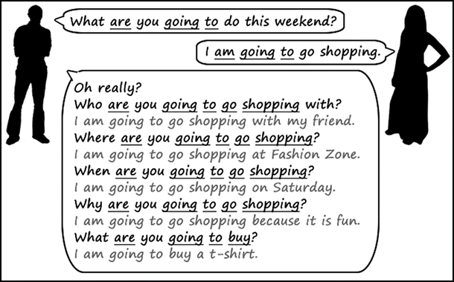 | 35 minutes  T – Ss  SS- SS
Assessment: Self-Assessment Can do statements:
Teacher asks ss to check or cross the activities they feel they can DO:
1- I can copy some familiar words, characters, or phrases.
2- I can tell what I am going to do in some days
3- I can describe some of my following personal activities.
Post-task | Role play:  In groups of 6, ss will create a role play related to a “friends meeting” in which they will say their names and mention the different activities they will do for the weekend.  T must create the groups considering the fact that every group must have advanced and elementary learners. The objective is to be even with the groups and help them all to speak. | 60 Minutes  ss- ss
Assessment: Peer assessment. 2 stars and a wish. T gives every member of the groups a chart with 2 starts and 1 wish to be filled out with the information from another group member
I like…

It was good that…

I wish that next time you ….

Wrap-up | Round table.  T asks ss to sit all around the classroom and he requests them to say now what they are going to study, to do, to buy in the future. T encourages them all to start by saying: I am going to  T gives his own examples:  I am going to study a masters in education.  I am going to travel around the world  I am going to buy a big house  I am going to be the best teacher for you | 30 minutes  T- ss
 | Assessment: T takes notes of every ss in order to have an accurate grade of each ss process.

List a series of ideas of how this plan can be methodologically adapted so other teachers can implement it in their own educational context.
Implementation alternatives
Have students write out answers to the question sheet. Go around the room to help individual students and check that students are answering using the correct form.

Write the key word for each category based on the content of this plan. For example:
Topic: environment Skill: reading Linguistic: should Vocabulary: animals, environment
Key words
topic | Skill | linguistic | vocabulary | grade
My future life | Writing and speaking | Future with going to | Shopping  Study  Work  Some professions | ^{7th}

