INSPIRING TEACHERS
ELT PLAN TEMPLATE

Author
Teacher´s name | Dalia Patricia Hernández Pabón
Email | hdalia506@gmail.com
School | Institución Educativa JUAN PABLO II

Lesson plan | Activity plan | Task plan | Project plan
 | x

Author’s remarks
This plan is easy and ready to use. It is useful to help students build vocabulary and start practicing speaking and communicative skills.

Grade | Length of activity | Number of students |  | Average age
sixth | 30 minutes | 25 |  | 11
Area |  | English level
Rural x | Urban | A1 x | A2 |  | B1

Curricular Focus / Axes
Environmental / Sustainability Education
Sexual / Health Education | x
Construction of Citizenship / Democracy / Teenagers
Globalization

Topic | Parts of the body
Module / Unit | Module 2
Language focus | Language Function | Language skills | Vocabulary
 | Describing your body and what you can do with it | Listening, writing and speaking | Head, neck, arms, legs, feet, hands, knees, chest, face.
Principles / approach | Task based learning

Learning objectives
Aim | By the end of this activity, students will be able to use vocabulary related to human body to describe what they can do.

Materials needed
Internet, computer, video beam, small pieces of paper, annex 1

Stage | Procedure | Time and Patterns of interaction
Pre task | Ss watch the following video and repeat the body parts mentioned  https://www.youtube.com/watch?v=SUt8q0EKbms | 5 minutes  Whole group
 | Assessment: T monitors and provides feedback on language and answers to the worksheet.
While task | In pairs, SS complete the crossword puzzle based on the description given for each body part. (Annex 1) | 10 minutes  Pairs
Post task | T gives each student a body part written on a small piece of paper and they must write a sentence describing what they can do with it.  Then T gives students a sheet with a blank body. (https://busyteacher.org/18147-body-parts.html). SS must walk around the room asking others what they can do with their assigned body part.  - What can you do with it?  - I can listen to music.  - Ears!  Ss share the description and the listener has to guess the body part and add it to the image. Once they have completed them all, they are done! | 10 minutes  Mingle  Whole group

Implementation alternatives
If the T has more than 25 students in their lesson, they can divide the group into two smaller groups for the mingle activity, so they can work in two different parts of the room and mingle with more people and participate more. If you do not have an internet connection at school, you can download the video at home and bring it to the classroom in a memory stick.

Key words
topic | skill | linguistic | vocabulary | grade
Parts of the body | Vocabulary building | NA | Parts of the body | 6th

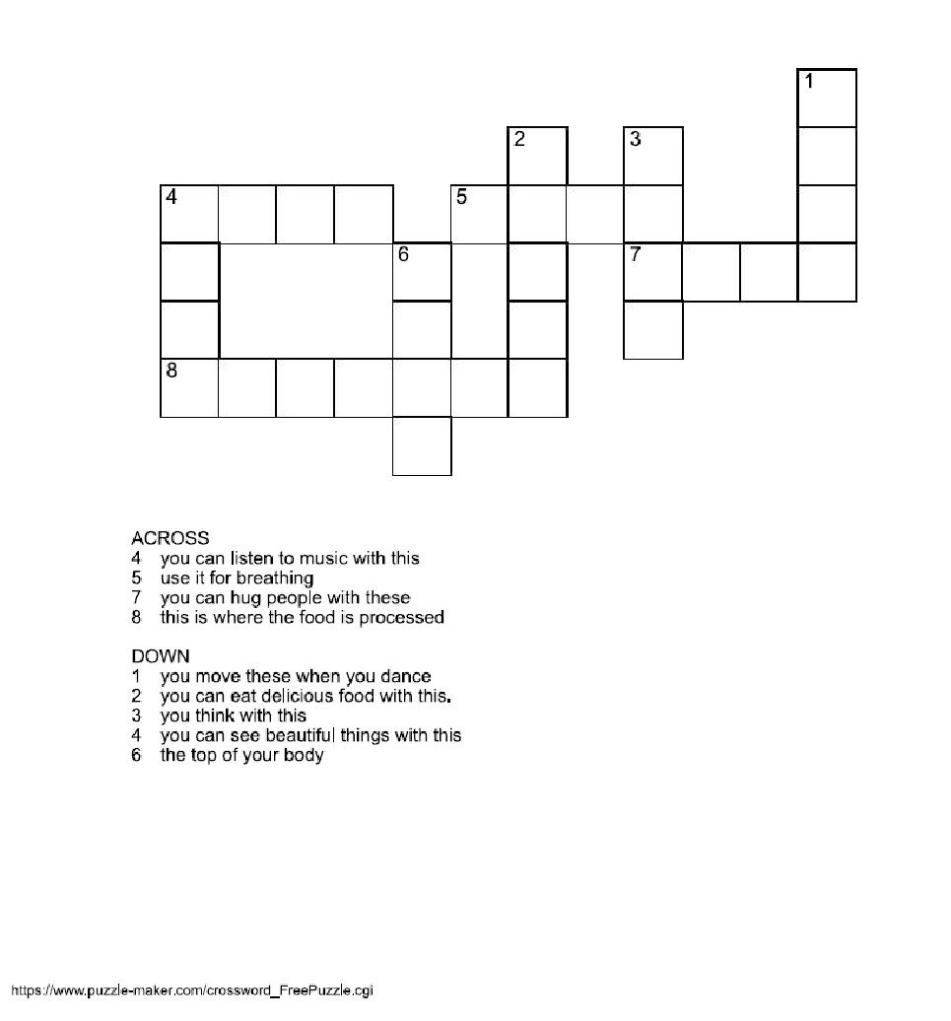
Complete the following puzzle with parts of the body. Use the clues to help you

