INSPIRING TEACHERS
ELT PLAN TEMPLATE

Author
Teacher´s name | Sandra Milena restrepo Solarte
Email | Samireso@hotmail.com
School | General Santander in Calarcá,

Lesson plan | Activity plan | Task plan | Project plan
x

Author’s remarks
This plan gives the opportunity to explore students’ own culture and learn from others’ regarding fast fashion habits and some urban tribes; it is a valuable tool to let students know other cultures, points of view and helps them be tolerant and respectful acknowledging we are all different.

Complete with the information about your students
Grade | Length of lesson | Number of students |  | Average age
Tenth | 2 hours | 21 |  | 15
Area |  | English level
Rural | Urban X | A1 X | A2 |  | B1

Curricular Focus / Axes
Environmental / Sustainability Education | X
Sexual / Health Education
Construction of Citizenship / Democracy / Teenagers | X
Globalization

Topic | Fast Fashion and Urban tribes
Module / Unit | Unit 1/ Lesson two
Language focus | Language Function | Language skills | Vocabulary
 | Valuing and respecting other’s opinions | reading  Writing | Clothing  Accessories
Principles / approach | Project based

]

Learning objectives
Aim | By the end of this lesson, students will be able to value and respect the opinion of others.
Subsidiary aims | By the end of this lesson, students will be able to …  - Assume a critical position about academic and social subjects of interest.  - Distinguish expressions related to fashion.

Materials needed
Tv
Images
Dictionaries
English Please Books

Stage | Procedure | Time and Patterns of interaction
Warm up:  Ice-breaker | T Introduces some fashion practices worldwide through images and videos.  Diagnostic assessment:  T asks SS to brainstorm on fashion practices.  Ss try to describe their favourite outfits. | 10 minutes  T-SS  SS-SS
Stop and go assessment
Students create index cards with a large green marker circle on one side and red on the other. If they are following along and understanding the lesson, the green side of their card is upright and visible to you. When they do not understand something and need clarification, they flip the card to show you the red side.

Introduction  Introducing language  Pre-? | Classification  T Ask SS to recognize and classify similarities and differences of some urban tribes in their context.  Feedback according to the classification | 15 minutes  Pair work
Practice:  Controlled practice  While-? | Reading practice  SS Make a reading about urban tribes and fashion at the EP book. They share ideas and then they check the reading comprehension exercises.  SS identify pros and cons of fast fashion practices.  Feedback according to the reading comprehension. | 30 minutes  Individual work  10 minutes  Individual work
Assessment: Traffic light assessment
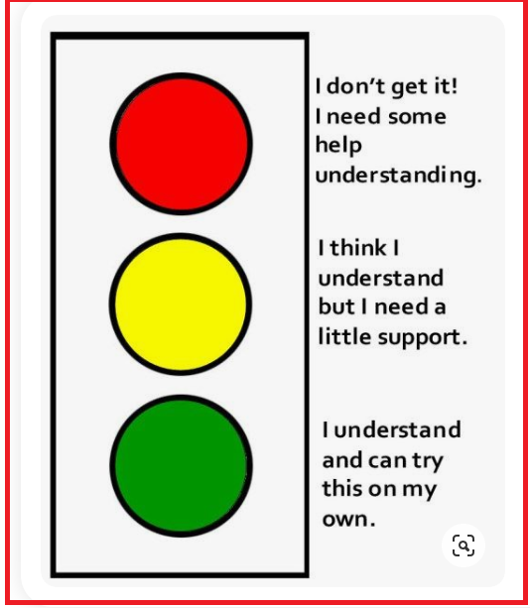
Production:  Freer practice  Post-? | Role play  Students prepare and represent known situations regarding fast fashion.  Feedback regarding the most common mistakes in the performances. | 45 minutes  Group work
Assessment:KWL technique
After performing the role play ss will write down in the KWL format what they know, what they want know and what they learned about the topic
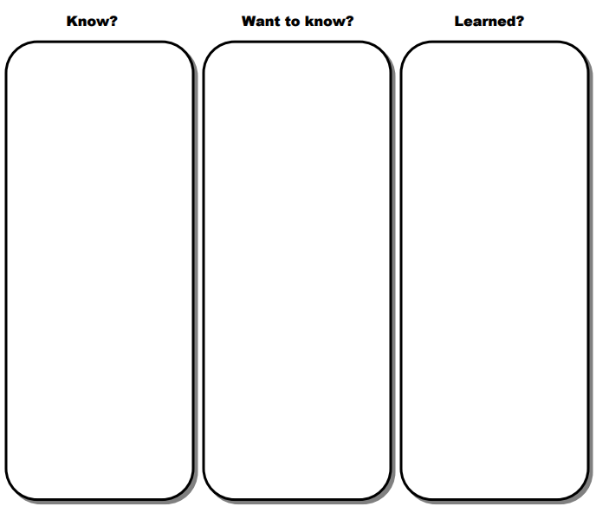
Wrap-up | Testing:  Students describe some current fast fashion practices and explain their similarities and differences.  Feedback | 10 minutes
Assessment: Learning Logs
After describing current fashion practices ss will write down on the learning log the following statements

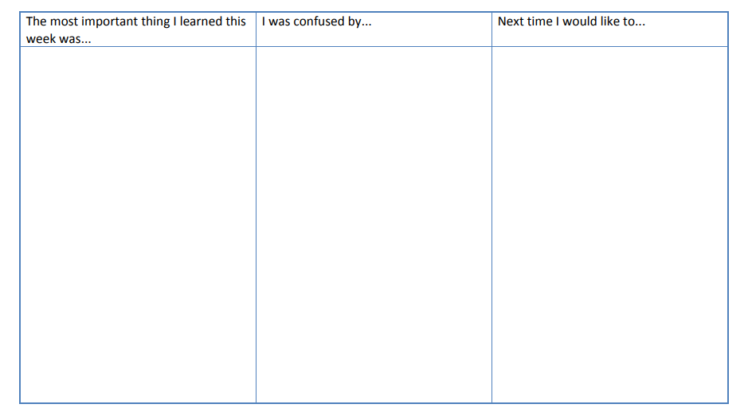

Implementation alternatives
Ss describe the urban tribes they are familiar with.
T analyse the effects of responsible and irresponsible fast fashion practices and its consequences.
Ss create a chart of comparison and contrast of fast fashion.

Key words
topic | skill | linguistic | vocabulary | grade
Fast Fashion  Urban Tribes | reading  Writing | Expressing opinion | Clothing  Accessories | Tenth

