INSPIRING TEACHERS
ELT PLAN TEMPLATE

Complete with the information about you
Author
Teacher´s name | MARÍA ROSA MATALLANA PÉREZ
Email | mmatallanaperez@yahoo.es
School | I.E GRAN COLOMBIA

Select the type of plan
Lesson plan | Activity plan | Task plan | Project plan
 |  | X

Write a few lines about the usefulness of this plan for the Colombian English teachers
Example: This lesson plan gives the students a chance to know about you, their new teacher, and it also gives you a valuable opportunity to assess your students' level. It can also be a useful and productive class if you ever find yourself substituting a class at short notice.
Author’s remarks
This lesson plan allows you to work different expressions students should / Shouldn´t use to avoid bullying and conflicts within the classroom. Also, it opens the possibility to forgiveness and reconciliation since there are many socio-emotional elements that will take place in this lesson.

Complete with the information about your students
Grade | Length of lesson | Number of students |  | Average age
7th | 90 min | 25 |  | 13-15
Area |  | English level
Rural | Urban X | A1 X | A2 |  | B1

Select the curricular axe or focus
Curricular Focus / Axes
Environmental / Sustainability Education
Sexual / Health Education
Construction of Citizenship / Democracy / Teenagers | X
Globalization

Complete with information about the content and methodological approach of the plan
Topic | Avoiding Bullying and Conflicts
Module / Unit | 2 - Democracy and Peace
Language focus | Language Function | Language skills | Vocabulary
 | Expressing positive language to avoid bullying at school | Writing | Positive qualities: tolerant, honest, peaceful, friendly.  Negative qualities: rude, aggressive, disrespectful, unpolite.
Principles / approach | Task-based learning

In “Aim”, state what the learning goal is, in other words, what you want your students to achieve by the end of the session.
In “Subsidiary aims”, relate the language skills (communicative and linguistic) students need to master in order to achieve the main aim of the lesson. Make sure the aims are learner-centred, specific, measurable, achievable, realistic, and action oriented.
Learning objectives
Aim | By the end of this lesson, students will be able to recognize and use positive and negative language towards avoiding bullying and conflicts in the classroom in a written way.
Subsidiary aims | By the end of this lesson, students will be able to …  - Distinguish between positive and negative language towards bullying and conflicts.  - Use the expressions should be / shouldn’t be.  - Write short expressions related to avoiding bullying and conflicts in the classroom.

List all the materials needed for this plan. Please, do not include any picture or photograph.
Materials needed
- English dictionary
- Paper (poster)
- Markers
- Notebook
- Board
- Crossword worksheet (designed by the teacher).

Write the name for each state of the plan. Then in the “Procedure”, write a detailed description of what the teacher and students do at each stage of the session.
Be sure to be thorough so any teacher can follow this plan. Write the procedure in third person and present tense.
Use these conventions: T= teacher S= students Ss= students
Stage | Procedure | Time and Patterns of interaction
Warm up:  Ice-breaker | T greets SS and asks them to close their eyes. Once SS have their eyes closed, T tells them to start walking around the classroom carefully. When T says stop, SS are going to meet the person that is closest to them ang give him/her a hug with the eyes closed. Do 3 rounds.  Then, T asks SS to remain with their eyes closed and think about someone who has told something bad to him/her that made them feel sad or angry. Once SS identify that person, T tells SS to forget about that moment and to give an imaginary hug to that person. | 15 minutes  T-SS  SS-SS
Assessment: Self-assessment. T asks SS to write down on their notebooks some Can do statements related to the topic:

Consider these examples:
I can respect my classmates
I can avoid bullying
I can help my classmate when he/she needs it
I can be tolerant and patient
Pre-task | T gives SS a crossword to find some words related to the class’ topic. They will need these words to complete the task. SS work in pairs.  Word bank:  6. Aggressive  5. Bossy  8. Helpful  7. Offensive  1. Polite  3. Respectful  4. Rude  2. Tolerant  Use the following crossword as an example:  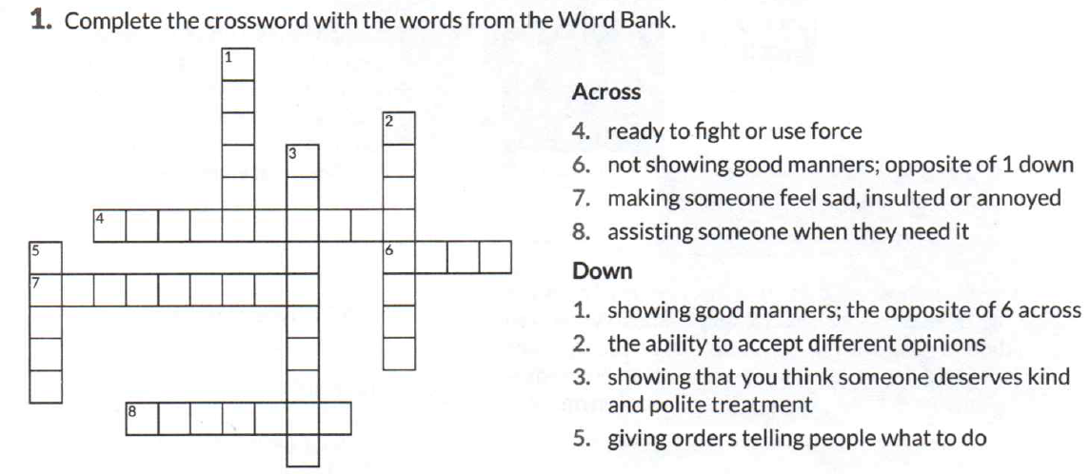  SS can use their dictionaries to look for some unknown words. T monitors and helps out when needed. | 15 minutes  SS  Pair work  Group work
Assessment: T provides feedback by monitoring SS work. T moves around the classroom explaining (representing with his/her face or body expressions) some of the unknow words. T never tells SS the translation of words.

At the end, SS socialize their answers and check out if everyone has the same answers. T confirms the answers.
Task | Now, SS have to make a chart on a piece of paper and classify the previous words between positive and negative attitudes towards avoiding bullying and conflicts in the classroom.  Positive Negative  - Helpful - Polite - Respectful - Tolerant - Aggressive - Bossy - Offensive - Rude  Now, T explain on the board how to use the expression should be /shouldn’t be with those words that they have been working in class. For example:  I should be respectful / I shouldn’t be aggressive  After the explanation, SS have to write I should be / Shouldn´t be for every word in the chart.  T asks SS to stand up and meet 2 more classmates. (This groups are made by T, depending on the amount of SS there is in each classroom).  In groups of 3, SS have to make a creative poster in which they use the expression I should be + 2 of the positive words they just learned in the previous activity. Besides, SS have to come up with 3 new words to add to their posters. | 30  SS  T – SS  SS  Group work
Assessment: CAT (Hand signal). T asks SS to close their eyes and show thumbs up or down to the following expressions:

I should be tolerant (thumbs up)
I shouldn’t be rude (thumbs down)
I shouldn’t be aggressive (thumbs down)
Etc.

If there are SS showing a different or opposite sign, T explains again a little bit the use of the expressions and the meaning of them.
Post-task | T asks SS to come in front and present their poster to the class. SS have to read the expression in English and promise they will start using and practicing those expressions from now on. T leads a compromise for SS in which they are going to monitor behaviour in the classroom and are going to promote the use and practice of each expression. | 20  T - SS  SS - SS
 | Assessment: T checks spelling and the use of the expressions on the posters, then asks SS to choose their favourite poster from other groups. SS write down in their notebooks the expressions they take from that poster. SS promise they will start practicing them from now on.
Wrap-up | T asks SS to make an entry in their learning journals. SS have to write the expressions they will start using and practicing. Also, SS should write about the importance of practicing these expressions to avoid bullying and conflicts within the classroom. | 10  SS
 | Assessment: Self-assessment. Learning journal.

List a series of ideas of how this plan can be methodologically adapted so other teachers can implement it in their own educational context.

Implementation alternatives
This plan can be implemented in any context, no matter if it rural or urban. Teachers can use different words for the crossword, depending on students’ level. Also, the poster activity may vary. You can, for example, have students making a paragraph, a role play, writing a poem, song, etc.

Write the key word for each category based on the content of this plan. For example:
Topic: environment Skill: reading Linguistic: should Vocabulary: animals, environment
Key words
topic | skill | linguistic | vocabulary | grade
Avoiding bullying and conflicts. | Writing | Should be / shouldn’t be | Helpful, aggressive, rude, tolerant, respectful, polite, offensive. | 7th

ss

